# Paraphrase nhóm tuổi

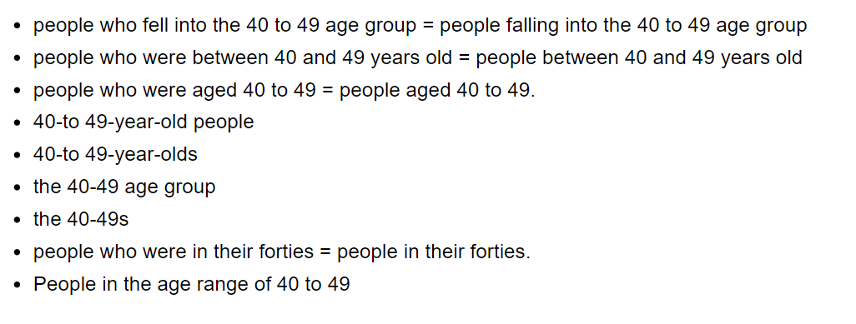

3 different forms/modes/means of transport

Adulthood: 20-40 aged group

Train user = rail passenger

Levels of joblessness/unemployemnt = the proportion of people who were unemployed/ jobless

Poor human= peple living under the poverty / in extremly poverty

# Paraphrase mấy cụm tăng giảm

1. Significantly rose

* Experience a marked rose
* Undergo subsa growth
* Witness a notable upward trend
* Notice a signi surge
* Register a remarkable

1. Slightly rise

* Experi.. a marginal rise
* Undergo modest growth
* Witness a minor upward trend
* Note a slight boost
* Undergo a minor

1. A is much higher than B

* A marginally excedd B
* Shows a minor signi..ly higher than B
* A exhibits/demon.. a minor rise compared to B
* A far/markedly/vastly( outpaces, surpassed) B, with accompanying figure being

1. With __% participaitng in this activity

* Engaging in this activity
* Taking part in this___
* Being involved / partaking / being a part of/ being included /take part /joining /____

1. A was more interested in A compared to B

* A exhibited a higher level of interest in A than in B
* A displays a grater preference for A compared to B
* A showed a stronger inclination towards A in contrast to B
* A expressed a greater attraction to A as opposed to B
* A had a more pronoued interested in A in comparison to B
* A revelated a more sigi.. prefe..ce for A over B

1. A is slightly higher than B

* Is marginally than
* A achived a %, with B colsely behind at x%
* A was %, closely followed by B with the fi..of%

1. X2,x3,x4

* A witnessd a ..fold climb compared to B
* __of A was triple that of B
* A exceed / surpassed that of B __fold

1. Max

* Maximum measurement
* Recorded the topmost figure
* The greatest numerical amount
* The highest data point
* Displays the topmost value

1. A was equal to B, at x% each

* A,B shared an equal proportion, both at _%
* ____ exihibited ____ distribition, both at _%
* ____ recorded____percentage, each at _%
* ____ accounted for the same propo, both at _%
* S + were indentical, both at _%
* S + were equivalent, each at _%
* S + reflected an equal contribution/ representation

1. Rise graduaaly

* Experience a gradual rise
* Witnees a steady upward trend

# Parapharse CT

A is far higher than B = A overtake B by a wide margin: A > B rất nhiều

A is lower than B=A is drawfred by B

A small number of = a mere minority of: 1 số lượng nhỏ

A shows a different trend = A bucks the trend: có xu hướng khác

Have the same figures = share comparable figures : có cùng số liệu

Increase back slightly = Experience a small rebound: Tăng trở lại

Slow down = slacken

A has quite the same trend as B = A is matched by a roughly similar trend: A có xu hướng giống B

A is different=A is a noticeable execption: là 1 ngoại lệ

Can be seen in most categories = roughtly the norm in: có thể đc nhìn thấy ở hầu hết các nhóm

# Gặp 4 đối tượng trở lên

A was most significant, the B,C and lastly D

A was highest, followed by B,C and finally D

A was highest, while B was lowest with C accounting for__% and D ___% in between

# Extreme: bar chart

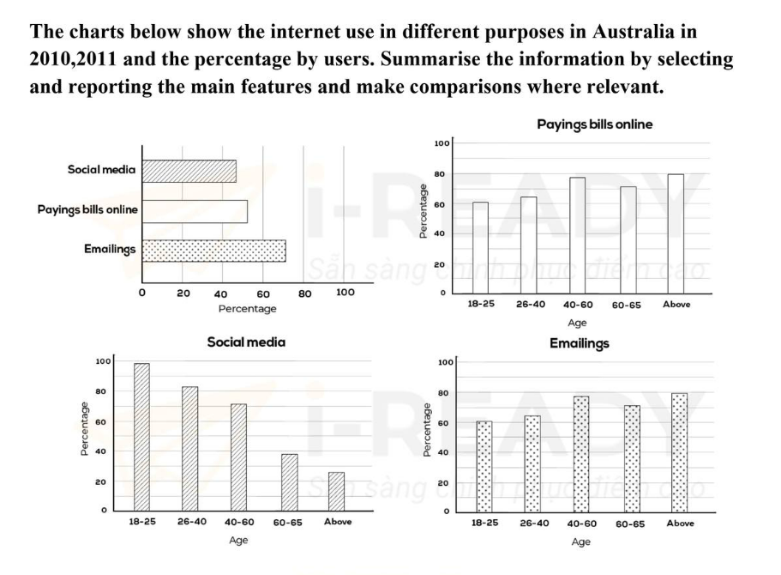

The bar chart illustrates the proportion of Australian people using three various service of internet, including social media, paying bills online and emailings and percentage per person, between 2010 and 2011.

Overall, the rate of residents using email for working was highest according the generic glance. Also, the rate of young people using social media made up the largest proportion while elder people was object who prefering to read mail and paying online more than.

On the common ground, the percentage of citizens connecting to internent for sending and receiving email in working was nearby 70%. This is followed by those who selecting payment via internet and social media form with a half and 47% popluation, respectively.

Regarding the rate in the three accessing form in internet per person, the percentage of individuals accessing internet for paying online shared comparable figures and trend with that of those who approaching email for serve working, lowest to 60% of 18-to-25 age group. Similarly, the oldest population group involving online payment reached around 60% to 80%, equal to that of group using emailings and larger than over 61% compared to residents of 26-to-40 group. Meanwhile, social networks was field of entertaiment attracting younger people in Australia with the rate of over three-fifth in population total, whereas the percentage of elderly people significantly lower than, approximately one-fifth.

# Mix chart: 17/2/2024

**The chart and graph below give information about three categories of workers in Australia and the unemployment levels within those groups. Summarise the information by selecting and reporting the main features, and make comparisons where relevant.**

The bar chart compares the export earning value in five different factors while the table illustrates the proportion of changing by value between 2015 and 2016. Overall, while the percentage of gem and jewellery decreased, the opposite was true for other categories accordingly table. In bar chart, petroleum products earning was the highest value and that of argicultural products least with unchaged data.

Regarding the bar chart, petroleum products value in 2015 was highest (60 billions), higher than double that of argicultural products while textitle was lowest and between engineered, gems. Until 2016, the gradually upward trend can be seen in three group, exception gem-jewellery (from 1 to 10 billions). Specially, export earning for argicultural products still remained around 30 to 31 billions dollar during the period. In the table, changing speed of petroleum products earning rose by 3%, lower than 5.18% and 8.5% that of gem-jewellery and engineered goods, respectively. By contrast, the figure for textiles sharply went up by 15.24% while that of agricultural recorded an extremely small growth by under 1%.

# 1 cái bar chart nào đó in recent day

The bar chart compares how many travellers went to museum within three different age forms, such as adult, under 15 and special exhibition over the last 15 years, starting from 1997. Overall, while the number of total and special exhibition visitors increased, the opposite was true for that of under 15-old people. Also, the figure for travellers who aged over-18 was highest during the period.

In 1997, young tourists in museum was 120000, lower than a half-double of adult visitors and higher than 28000 of special. Over the next 5 years, there was a slightly dropped by 10000 in children visiting museum. By contrast, during the same times showed a marginal rose to 29200 in the figure for special visitors whereas that of adult tourist was 1000.

From 2002 to 2007, there was a quickly soared in the frequency of the visiting museum. The figure for over-18 aged visitors substantial expanded and recorded the topmost value(at 0.4 million) in 2007, while that of exhibition travellers was lowest (over 37000) and 87000 people under fifteen in between. Meanwhile, the period between 2007 and 2012 was witnessed the slightly downward trend in the number of adult, under 15 group to 380000, 82300, respectively, except exhibition people(rose by 5000 people).

# Natural process: Apple

* As a result after refining, water which cleaned was moved to storage.

The diagram illustrates the production of concentrated apple juice. Overall, there are 11 main stages, beginning with harvesting, selecting best apples and finishing with it is delivered and sent to citizen.

The initial stage is farmers reap apple in garden and remove broken items, then it put through a roller for washing and sorting. After this stage is complete, apples are moved to grinder to crushed into thin apple slices which contain in wooden barrels. Next, workman spill apple slices out of these barrels to pressing machine. At step five, centrifuger is tasked that separates water from apple concentration.

In the subsequent stage, apple juice is complemented aroma which base on three creating taste machine in this place. Following that, it passed through essential two steps, including three layer filtration and up to 80 degrees Celcious pasteurization, suggesting that main purpose is demolish harzadous material or harmful bacterial. After completing this steps, lastly product – apple juice is filling poured in bottle, then packaged in containers and sent to truck, transported to market and serve consumers.

# Map

Phân chia data

Gắt hơn trong việc sử dụng từ chỉ phương hướng

Ko xuất hiện la bàn => ko dùng NWES

Coi xem bài có ổn ko rồi mới đối chiếu với map

**Introduction**

Benefit: Decorating the eco-space for animals

The map show____ htai và tương lai

__________ in 123 and 456

==> The map/plans describe/ give information about the change to___ between and : miêu tả/ cho thông tin về nh sự thay đổi

Thiết kế ngoại thất: the exterior design

**Đề 20/3 ở BC Viettel**

The map illustrates some change to South Wing of Walton Museum between 2008 and 2012. Overall, South Wing experienced considerable transform during the period shown. The most noticeable differences between two map are all room in underground floor became larger and third house was built more floor and gable.

As can be seen from the map, entrance where connecting with path was replaced by entrance hall and terrace on the second floor. In addition, special exhibition room where underground floor remained unchanged and during the time. Moreover, reception room was still exist and functional transform into reception-cloarks room in 2012. Area on the third floor of center house row was used for building restauran and connecting with terrace.

Turning to the other features, stairs was demolished and replaced by lift, where located between two adjacent house row, which making the transportation to many floor easier. Besides, while reading room was remained unchanged, cloarks room in underground was replaced by childern play area. Meanwhile, self-service and exhibition room were built on respectively, the third and fourth floor.

**Overview**

Tư duy bef aft: nhìn 2 map: khác nhau nổi bật ntn, phía sau gọn vippro hơn thk 1

There have been significantly changes in the layout/design of____

The… now/in the future is more modern/spacious/organized compare to the past/the present.

There are new infrastructures/establishments such as… replacing…

…has been signifly renovated over the years, with features such as.. replacing…

Ex

* The provide diagram illustrates____

Once notable change is that + S + has/have been +V3 + location

* S = a park/ an office building
* V3 = {developed, built, constructed, erected}
* Location = (in the northwest of tower / to the west of the market)

**Paraphrare**

1. A was changed into B

* Transformed/converted/turned into B
* Replace by/repurposed as B
* A experienced a remarkable, culminating in the emergence of B
* The location previously occupied by A is now taken up by B
* B has taken over the site that was formerly occipied by A
* _____ asssumed the position where A was once situated
* Removed to pave way for/make way for/construct/build/erect B

1. A was move from__to__

* A was (relocated / shifted / transferred / displaced / repostioned) from__to__
* A underwent a transition, being relocated from__to__
* A underwent a transfer, shifting from__to__
* A was subject to displacement, being moved from__to_

1. A was made higher

* A was (enlarged/expanded/rise in size/upsized)
* A underwent a ( notable expansion / a subtan.. increase in size)
* A was subjected to a considerable size enhancement

1. show the changes that took place in A

* demonstrate the modifications/alteration that took place / occured in A
* Depict the tranformation that occured in A
* Display the transitions that took place in A
* Showcase the developments thet occured in A

1. A was located in the northern region in the map

* _____ located in the northely direction on the map
* _____ situated in the northernmost area of the map
* _____ postitioned __ part of__
* _____ situated __ portion of__
* _____situated in the upper part of__
* _____found in __ (NEWS)ward section of__
* _____ placed in__ area of__